7.IMPLEMENTATION OF BALANCED BINARY SEARCH TREE (AVL TREE) USING C++

AIM:
To write and implement a C++ program to create a balanced Binary Search Tree (AVL Tree) and perform insertion/update, searching, and inorder traversal operations while maintaining the balance of the tree using AVL rotations.

ALGORITHM :
Step 1: Start the program.
Step 2: Initialize the root of the AVL tree as NULL.
Step 3: Display the menu containing the operations: Insert/Update, Search, Display, and Exit.
Step 4: Read the user's choice.
Step 5: If the choice is Insert/Update, read the key to be inserted.
Step 6: Insert the key into the tree according to the Binary Search Tree property.
Step 7: Update the height of each affected node after insertion.
Step 8: Calculate the balance factor using the difference between the heights of the left and right subtrees.
Step 9: If the tree becomes unbalanced, identify the rotation case as LL, RR, LR, or RL.
Step 10: Perform the appropriate right rotation, left rotation, or combination of rotations to balance the tree.
Step 11: If the key already exists, update the existing key and maintain the tree.
Step 12: If the choice is Search, read the key to be searched.
Step 13: Compare the search key with the current node and recursively move to the left or right subtree.
Step 14: If the key is found, display "Key found in the tree"; otherwise, display "Key not found."
Step 15: If the choice is Display, perform inorder traversal of the AVL tree.
Step 16: Display the elements in ascending order.
Step 17: If the choice is Exit, display "Program terminated" and terminate the program.
Step 18: If an invalid choice is entered, display "Invalid choice!"
Step 19: Repeat the menu until the user selects the Exit option.
Step 20: Stop the program

PROGRAM:
#include <iostream>
#include <cstdlib>
using namespace std;
struct Node
{
int key;
int height;
Node *left, *right;
};
int height(Node *n)
{
return (n == NULL) ? 0 : n->height;
}
int max(int a, int b)
{
return (a > b) ? a : b;
}
Node* createNode(int key)
{
Node* node = new Node();
node->key = key;
node->height = 1;
node->left = node->right = NULL;
return node;
}
Node* rightRotate(Node *y)
{
Node *x = y->left;
Node *T2 = x->right;
x->right = y;
y->left = T2;
y->height = 1 + max(height(y->left), height(y->right));
x->height = 1 + max(height(x->left), height(x->right));
return x;
}
Node* leftRotate(Node *x)
{
Node *y = x->right;
Node *T2 = y->left;
y->left = x;
x->right = T2;
x->height = 1 + max(height(x->left), height(x->right));
y->height = 1 + max(height(y->left), height(y->right));
return y;
}
int getBalance(Node *node)
{
if (node == NULL)
return 0;
return height(node->left) - height(node->right);
}
Node* insert(Node* node, int key)
{
if (node == NULL)
return createNode(key);
if (key < node->key)
node->left = insert(node->left, key);
else if (key > node->key)
node->right = insert(node->right, key);
else
{
node->key = key;
return node;
}
node->height = 1 + max(height(node->left),
height(node->right));
int balance = getBalance(node);
if (balance > 1 && key < node->left->key)
return rightRotate(node);
if (balance < -1 && key > node->right->key)
return leftRotate(node);
if (balance > 1 && key > node->left->key)
{
node->left = leftRotate(node->left);
return rightRotate(node);
}
if (balance < -1 && key < node->right->key)
{
node->right = rightRotate(node->right);
return leftRotate(node);
}
return node;
}
Node* search(Node* root, int key)
{
if (root == NULL || root->key == key)
return root;
if (key < root->key)
return search(root->left, key);
return search(root->right, key);
}
void inorder(Node* root)
{
if (root != NULL)
{
inorder(root->left);
cout << root->key << " ";
inorder(root->right);
}
}
int main()
{
Node* root = NULL;
int choice, key;
while (true)
{
cout << "\n\n--- Balanced BST (AVL Tree) ---\n";
cout << "1. Insert / Update\n";
cout << "2. Query / Search\n";
cout << "3. Display (Inorder)\n";
cout << "4. Exit\n";
cout << "Enter your choice: ";
cin >> choice;
switch (choice)
{
case 1:
cout << "Enter key to insert/update: ";
cin >> key;
root = insert(root, key);
cout << "Key inserted/updated successfully.\n";
break;
case 2:
cout << "Enter key to search: ";
cin >> key;
if (search(root, key) != NULL)
cout << "Key " << key
<< " found in the tree.\n";
else
cout << "Key " << key
<< " not found.\n";

break;
case 3:
cout << "Inorder traversal: ";
inorder(root);
cout << endl;
break;
case 4:
cout << "Program terminated.\n";
exit(0);
default:
cout << "Invalid choice!\n";
}
}
return 0;
}

OUTPUT:

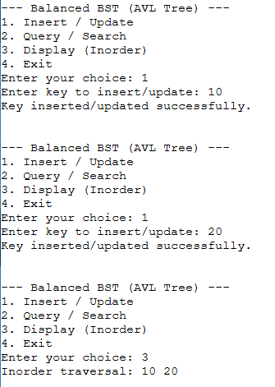

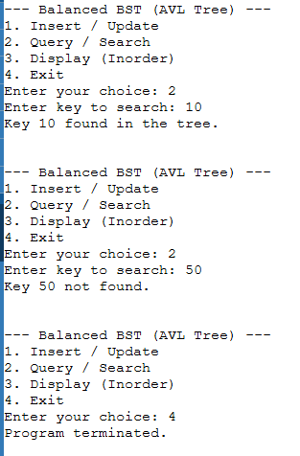
RESULT:
Thus, the C++ program for implementing a Balanced Binary Search Tree (AVL Tree) was successfully executed. The program performs insertion/update, searching, and inorder traversal operations while maintaining the balance of the tree using AVL rotations.

